Material’s Selection and Search

* *Material Types* are registered in General Information 🡪 Material Types 🡪 Register Material Type Form. Currently there close to 15 different categories of materials and can be listed in the drop down.

The list contains: *FERTILIZANTES, HERBICIDAS, INSECTICIDAS, INSUMOS VETERINARIO (?), INSUMOS Y REPUESTOS MAQUINARIA, HERRAMIENTAS Y MATERIALES, RIEGO, and MATERIALES DE OFICINA*

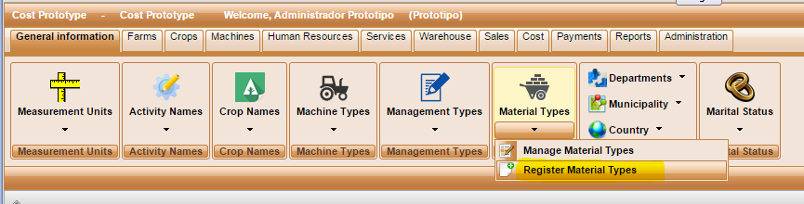

* *NEW –* ***include Material Type filter to Manage Materials Form.***

User should be able to narrow list of material by Type on **Manage Materials Form**

Material Type Filter should be added to Manage Materials Form to allow this functionality. “ALL” should be added to the drop down list as default option.

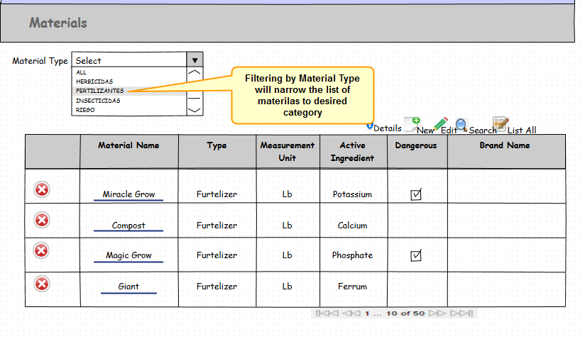

* NEW - Expand ***Material Search to include Type.***

Since there over 300 materials of various types in the Material Table, narrowing search by type will allow fewer records to be displayed.

*Search for material should include Material Type (category) and material name if known. If user doesn’t specifies type then “ALL” is used as default. If user doesn’t enter material name, system should list all the materials of selected category. It should be enough to enter just few initial letters of the name to perform “wild card” search.*

